HILLY FIELDS FOOTBALL CLUB
SEASON 25: 1991-92
Beckenham Hospital Veterans Cup
P W D L F A
3 2 0 1 10 7
Friendly 31 13 5 13 86 58
TOTAL 34 15 5 14 96 65

Apps Gls
Adrian Bennett 20 1
Damien Cole 2 0
Mark Cooper 23 4
Micky Davis 21 2
Steve Edwards 25 2
Ivor Felton 3 0
John Felton 25 1
Keith Foster 25 1
Malcolm Hill 23 5
Phil Hortin 13 0
Mike Jefferys 4 2
Phil Jesson 1 0
Howard Jones 23 27
Mike Lane 26 0
Shaun Litchfield 1 0
Ray Marchant 19 9
Kevin McCormick 7 0
Steve Morton 1 7
Jake Murray 1 0
Barry Naylor 5 0
Steve Quinn 3 0
Geoff Roberts 23 4
Tommy Salacuri 1 0
Alan Sayers 1 0
Charlie Shoppee 1 0
Albert St Clair 7 4
Ralph Stanton 7 2
Rick Symes 1 0
Terry Taber 20 8
Mario Vaz 33 5
Colin Walker 2 0
Dave Wright 33 8
OG 4

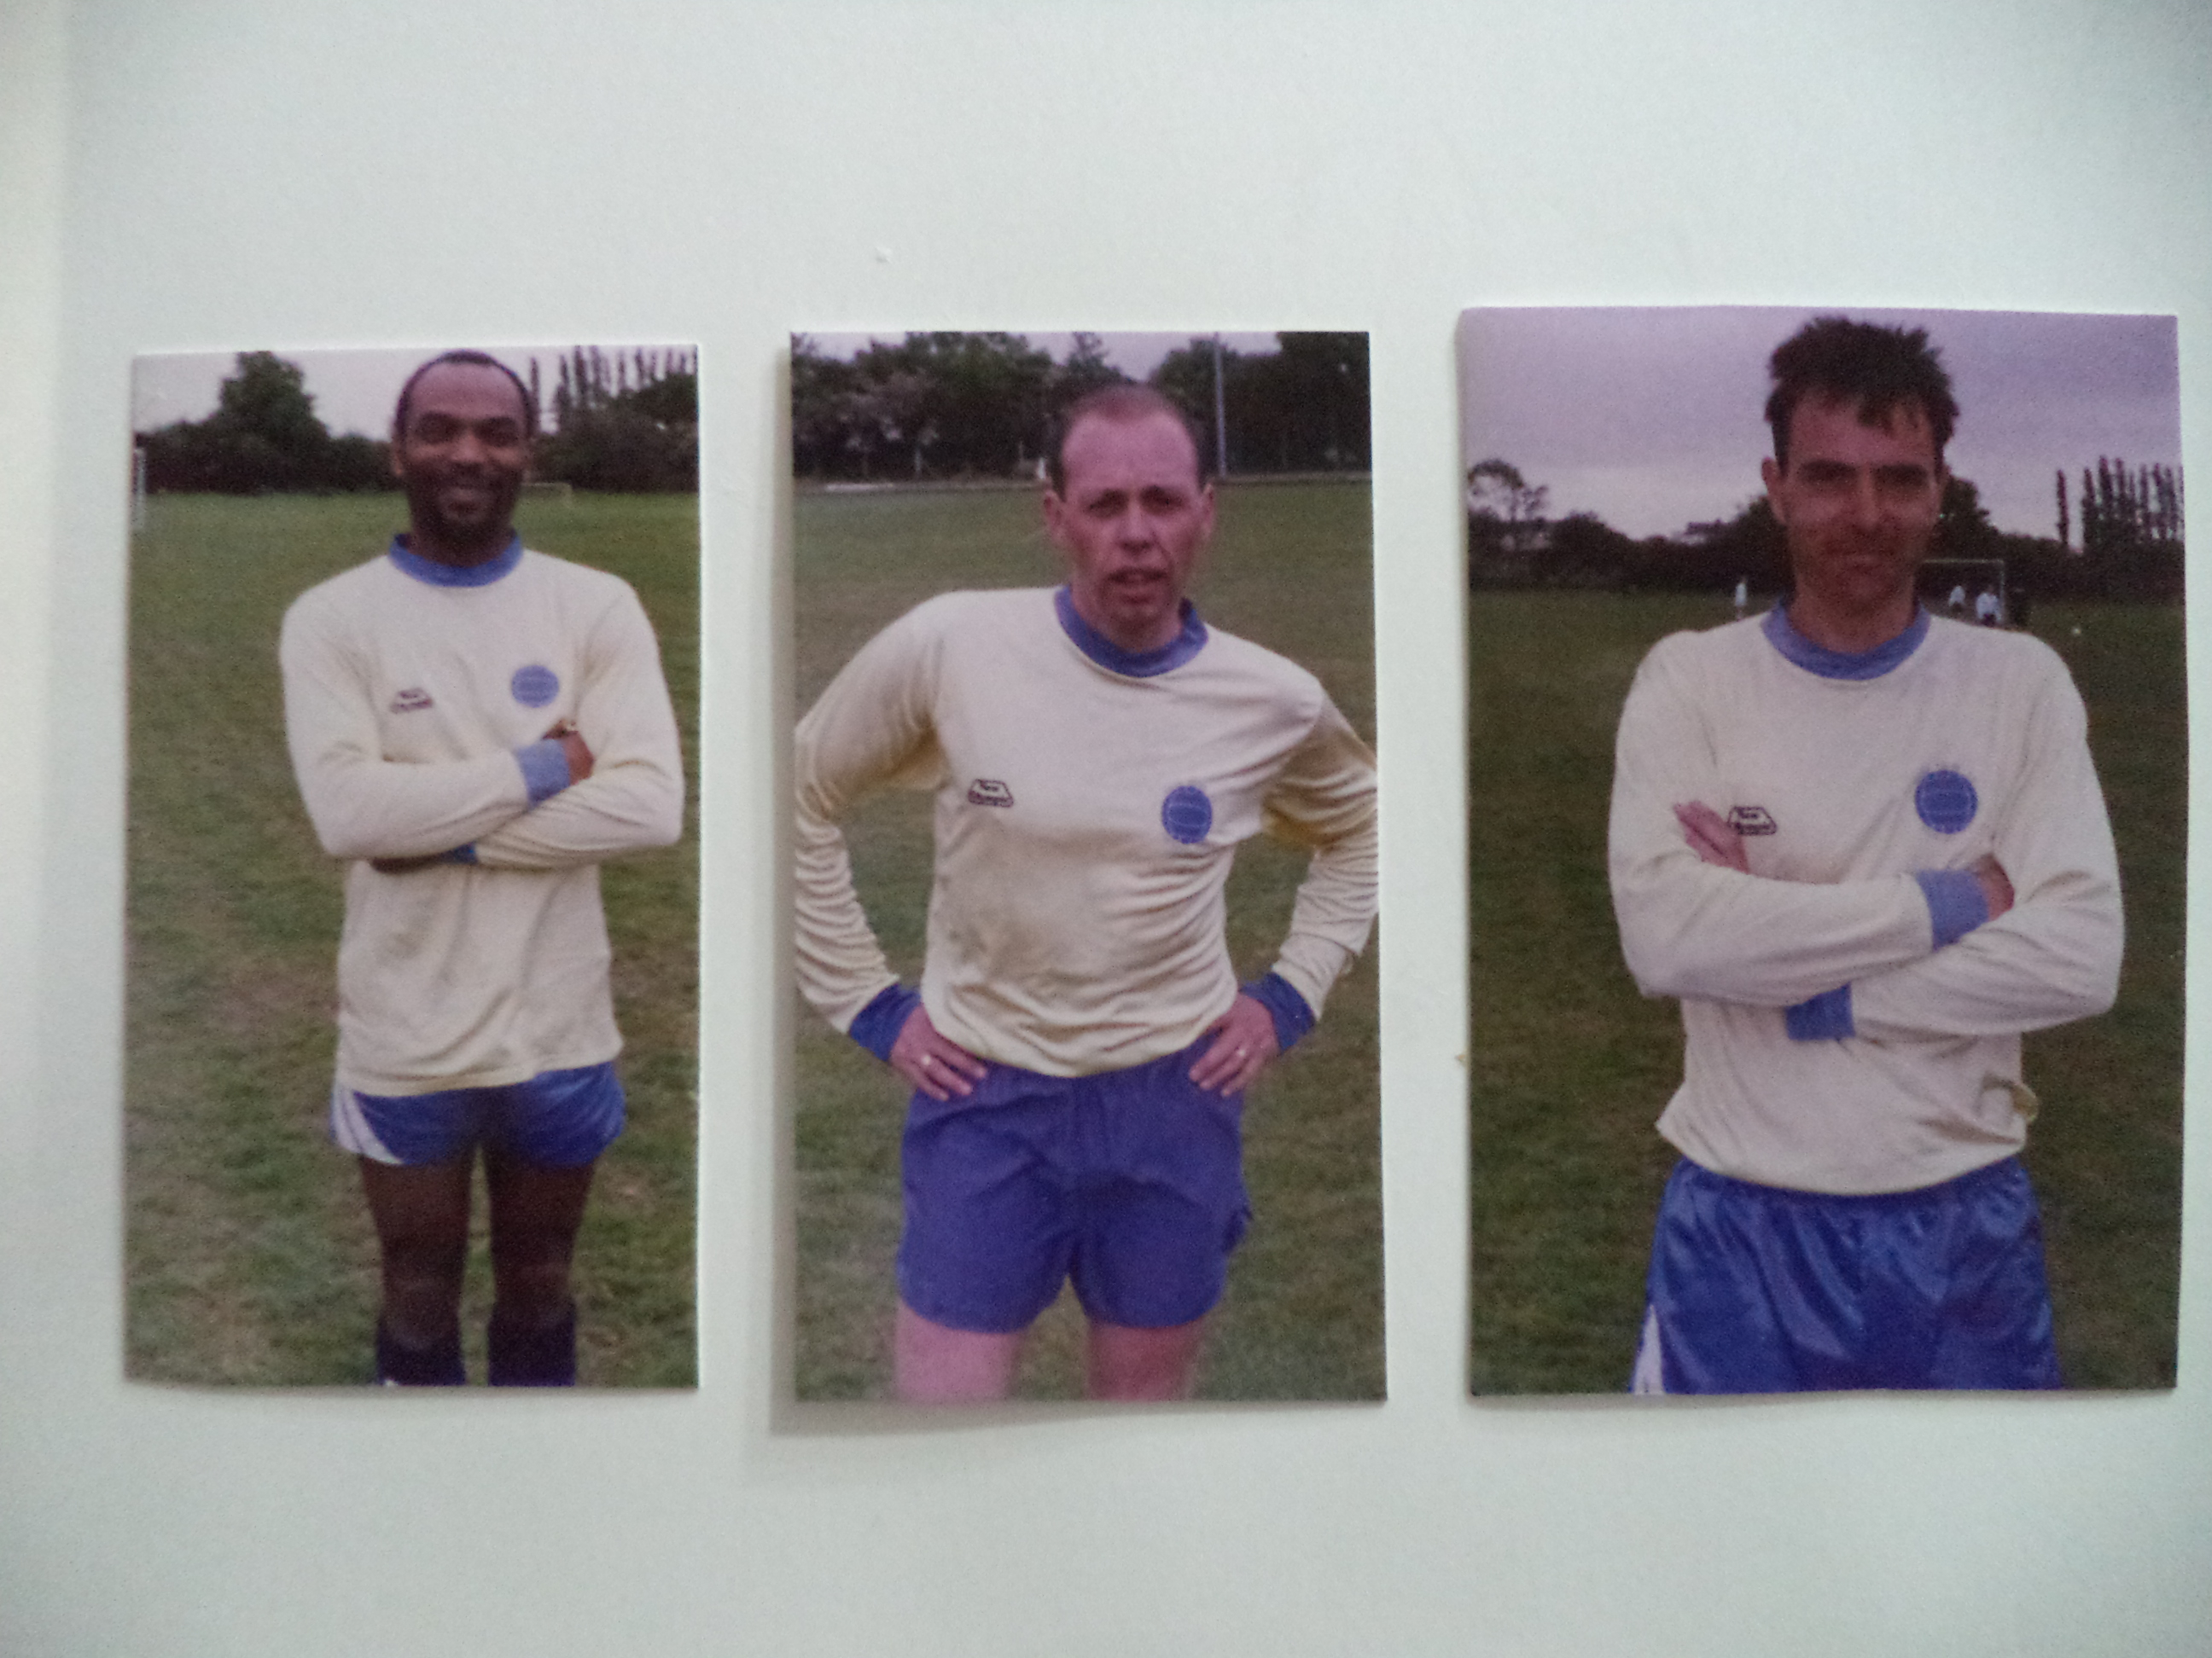
Albert St Clair Colin Walker Howard Jones

